**CS590BD Big Data Analytics and Apps**

**Third Increment Report – Group2**

**Motion Detector**

**Kommineni, Siva Krishna**

**Ponnam, Balakrishna**

**Boyanapalli, Swathi**

**Pathuri, Savya Sri**

**Summary:**

To brief out the implementation done in the prior increments we have completed the collection of the open source game, designing of the UI and sensor connectivity. In this increment we have made considerable progress in data collection and training the model. We have generated sample sequence files for actions based on the gestures and motion recognition. We used the web services for the generation of these files based on the training and testing data. This data is clustered using the K-means clustering and the formed clusters are trained in various sequence operations for the perfect motion recognition

**Framework Specifications:**

In this increment we made progress in the selection of the game and analyzing the direction movements present in it so that we can match it with the sensor tag direction movement. First we should collect the data, push it into HBase and host a restful web service using the Glassfish server. We are enhancing the connection establishment between the accelerometer data in the application file and the sensor tag accelerometer connections. Currently we are running the application on the emulator for searching the exact movements. The mobile client is entirely developed in Android and it is a native application for android users. The version supports from Froyo to Jellybean’s. We are using the K-means clustering to form clusters and analyze the motion of the data using the sequence file operations like training and testing.

**Application Specification:**

* **Software Specification**
  + Tools: Mahout, R, RHadoop, Android Development Kit, Eclipse Kepler
  + Operating System: Android
  + Development Operating System: Windows 8
  + Programming Language: Java 7.0
  + Databases: HBase, Hadoop

**Activity Recognition Scenario and Data Collection**

* **Devices/Sensors:**

## Sensors: TI Sensor Tag - CC2541DK-SENSOR

**Devices: Android devices**

* Bluetooth 4.0 compatible android device
* Android 4.3 or above OS
* GPS

**TI chronos Watch – EZ430-Chronos**

**Implementation:**

The implementation part typically consisted of following steps.

* Selection of an open source game.
* Enhance the application according to our requirements.
* Collection of data from game for required motions.
* Clustering and analyzing data and later train and test the data.
* Activity and motion recognition based on the available files generated.

First we need to deploy our open source game on an emulator to analyze the motions and actions based on the sensor tag movements.

Enhance the existing code for establishing the connection with the sensor tag. Later we collect the data from the game based on the actions.

The collected data is clustered using K-means clustering and later trained, tested using the sample web services for the generation of the sequence files.

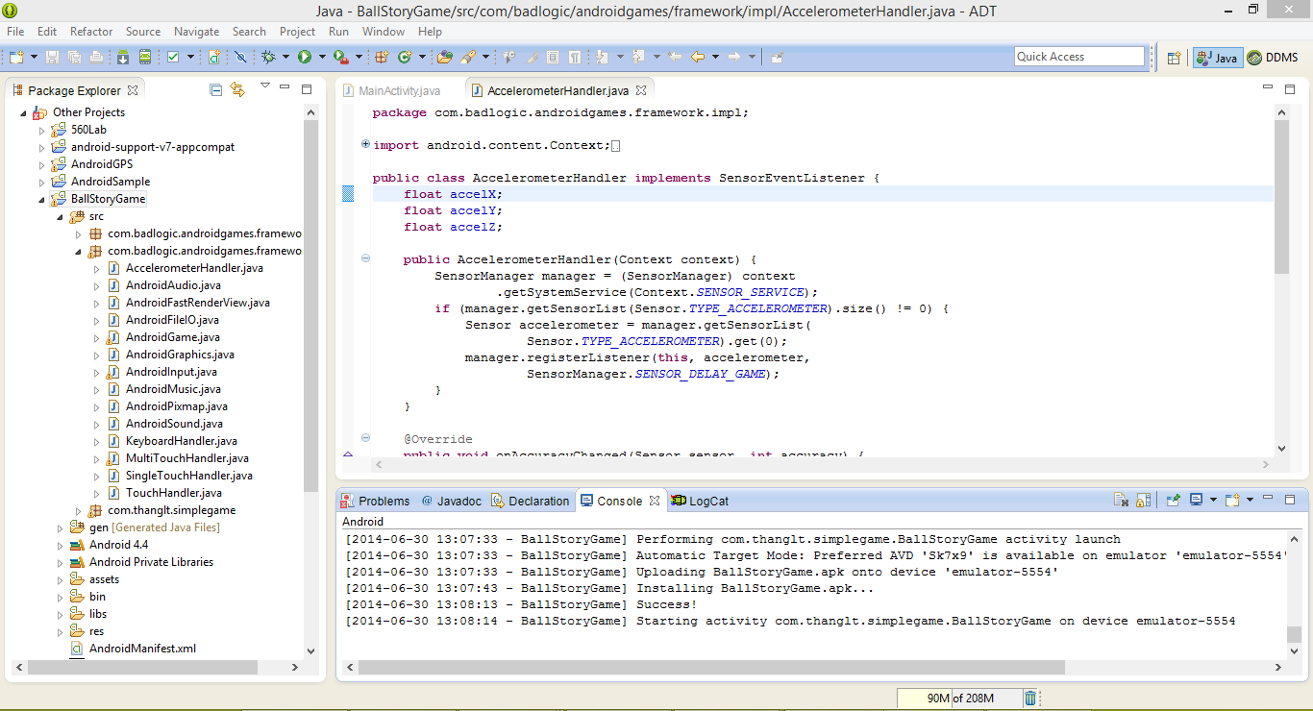

The below figures shows the sequence of basic operations in the open source game. First it shows the app named Sample Game in the UI. After launching it by clicking on the icon we get the page shown as below.

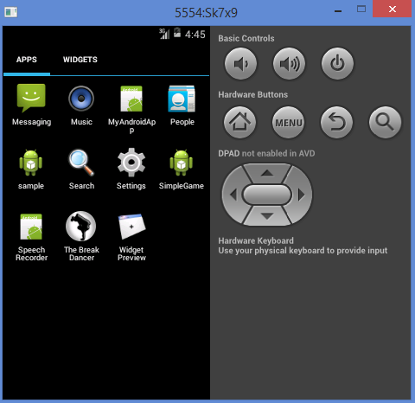 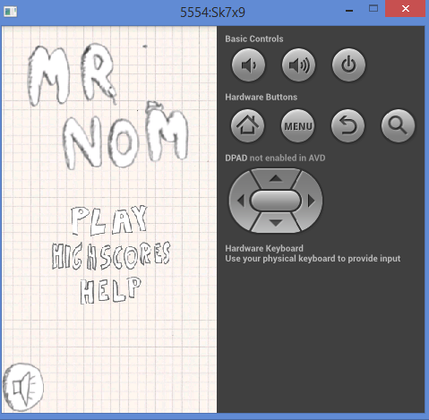

Later when we click on the play it asks to get ready to play the game. After touching the screen it starts moving the ball in all the directions based on the arrow key controls shown in the screen below. The ball moves in all the directions, While this movements we should collect the accelerometer readings for the movement of the ball.

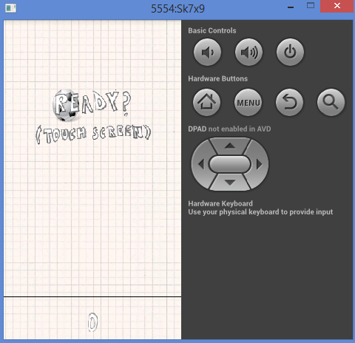 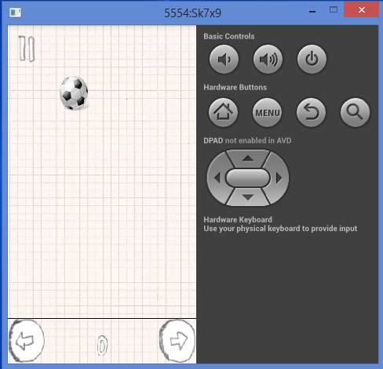 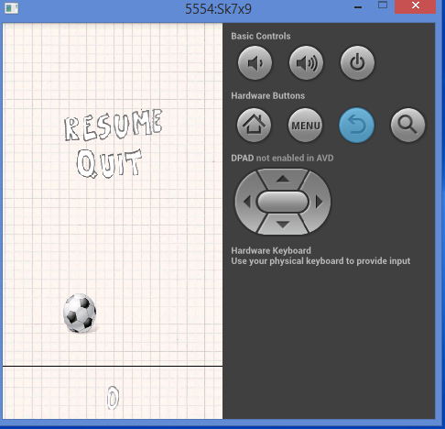

* We collect the data from these applications and then cluster, analyze it and compare them by using the machine learning algorithms to form grouping of the data based on the actions, direction of movements.
* The following screens show the file transfer and retrieval mechanism of the data collected from the application.
* It shows the file is transferred successfully.

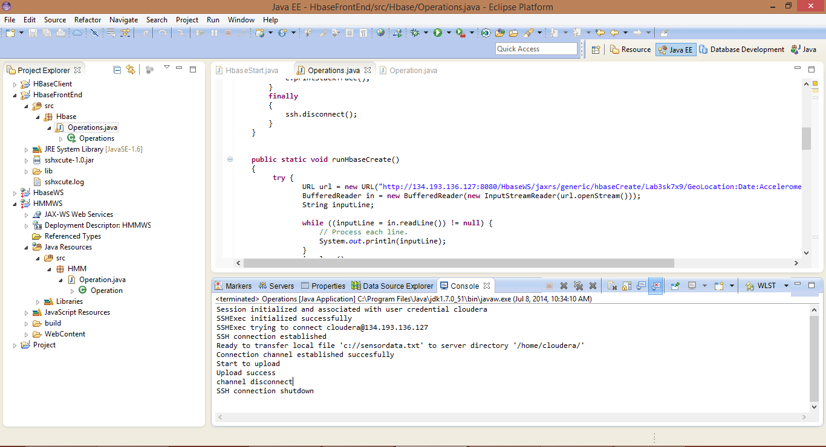

* Later we retrieve the data and save the file so that the saved data files are used for the training and testing purpose.
* The most important part later is the data preparation part where we prepare two files for testing and training the raw data which are tab separated.
* We transfer these files to the remote machine using the file transfer mechanism to perform further operations.

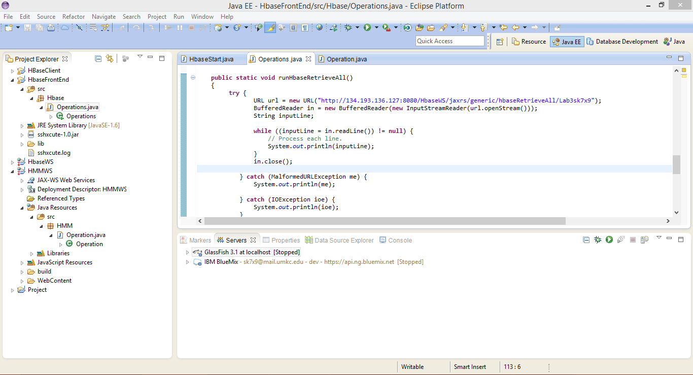

* **Performing Activity recognition:-**

To perform the Activity recognition patterns on the given data file we first prepare the training and testing data.

Later we use K-means clustering to perform the clusters of the data based on the approximations.

Basically we use three methods in the service they are

1. Training file operations
2. Testing file operations
3. Training and testing file operations

We provide the raw data as the input file for the generation of the output sequence file as follows.

The below shows the performed training file operation for activity recognition.

We should train the system if there are more number of actions present.

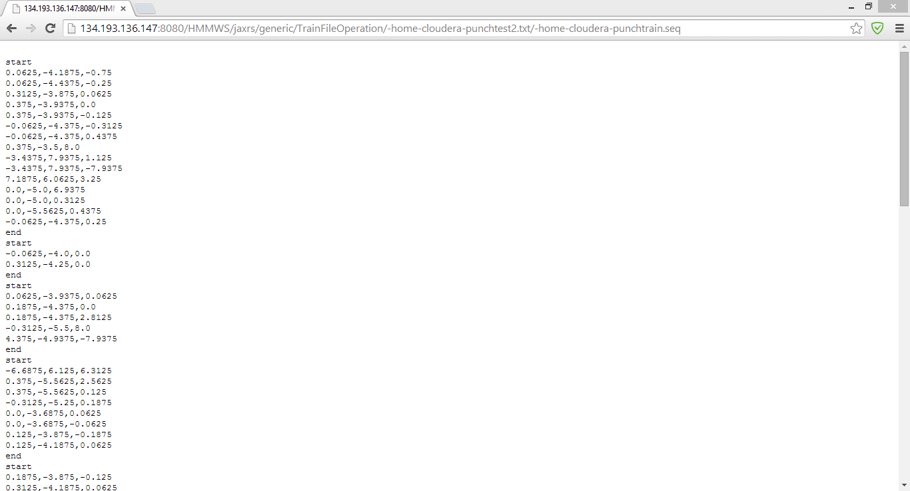

Later second operation is the generation of the output sequence file from the raw data as input.

The below screen shows the generated file after performing the testing file operations.

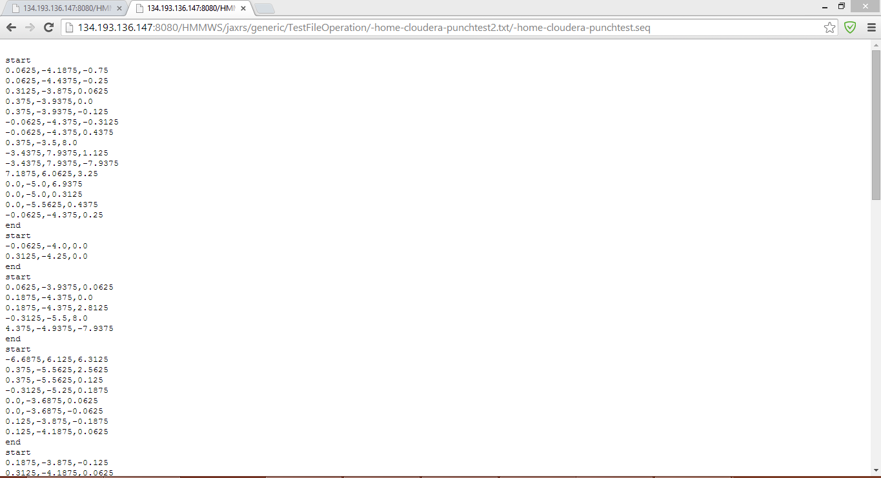

Later we perform both the training and testing operations as input sequence files to get the required output file.

The data trained is the combination of all the actions for the generation of the sequence files.

**Project Management:**

All the task planning according to the iterations are maintained in scrumdo and task allocation is shared equally among the team members.

<https://www.scrumdo.com/organization/umkc94/dashboard>

* **Fourth Increment:**

The tasks that will be included for fourth increment are:

1. Modify the existing features of game according to the application development.
2. Enhancements for connection between the available open source game and sensor.
3. Testing and training the collected data using web services.
4. Activity and motion recognition based on the available data.

The above mentioned tasks will be uploaded the scrumdo tool with specified timelines.